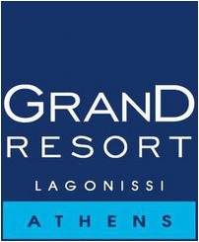

Data Subject’s Rights

Request Form

This form may be used to submit a request by the Data Subject in accordance with the provisions of the European Union's General Data Protection Regulation (GDPR).

**Submitter Details**

|  |  |
| --- | --- |
| **Name and Surname:** |  |
| **Address:** |  |
| **Telephone:** |  |
| **E-mail** |  |

Type of Request

Select the type of right’s request you are submitting regarding your personal data:

|  |  |
| --- | --- |
|  | *Withdraw Consent* |
|  | *Access* |
|  | *Rectification* |
|  | *Erasure* |
|  | *Restriction of processing* |
|  | *Portability* |
|  | *Object* |
|  | *Request concerning automated decision-making and profiling* |

**Personal Data relating to the request and status of the Data Subject (e.g., employee of ATTIKOS HELIOS, customer, supplier, etc.)**

|  |
| --- |
|  |

# Details of Request

|  |
| --- |
|  |

|  |  |
| --- | --- |
| **Signature:** |  |
| **Date:** |  |

This form should be submitted to the email address [dpo@grandresort.gr](mailto:dpo@grandresort.gr) or to the postal address of the company as Data Controller:

ATTIKOS HELIOS S.A. (GRAND RESORT LAGONISSI)

Address: Athens, 19 Amerikis St., P.C. 10672

Phone: 2103679000